Project Report: AWS Infrastructure Health Monitoring Dashboard

1. Executive Summary
This project demonstrates the implementation of an automated infrastructure monitoring solution on Amazon Web Services (AWS). By leveraging Infrastructure as Code (IaC) using Terraform, we successfully deployed a multi-tier architecture consisting of compute (EC2), storage (S3), database (RDS), and serverless (Lambda) resources, all integrated with a centralized CloudWatch dashboard for real-time health monitoring and alerting.

2. Project Objective
The primary goal was to solve a common Cloud Support challenge: "How do we ensure all critical infrastructure components are healthy and reachable?"
Key deliverables included:
- Network Foundation: Automated provisioning of a custom VPC with Public/Private subnets, NAT Gateways, and Route Tables.
- Core Infrastructure: Deployment of EC2, S3, and RDS using Terraform.
- Serverless Automation: Lambda functions for network connectivity testing and automated alerts.
- Observability: Real-time monitoring of CPU utilization, storage metrics, and a unified CloudWatch Dashboard.

3. Architecture Overview
The infrastructure was deployed in the us-east-1 region and consists of the following components:
- Network: Custom VPC, Public/Private Subnets, NAT Gateway, Internet Gateway.
- Compute: EC2 t2.micro instance acting as a Web Server.
- Storage: S3 Bucket for object storage logs/data.
- Database: AWS RDS (MySQL) instance for application data.
- Serverless: Lambda functions triggered by EventBridge for periodic network checks.
- Monitoring: AWS CloudWatch (Dashboards, Alarms).
- Orchestration: Terraform for state management and deployment.

4. Implementation & Execution Log

Phase 1: Infrastructure Initialization
The project began by initializing the Terraform backend and creating an execution plan to verify the resources to be created.
Action: Ran terraform init to download providers and terraform plan to preview changes.
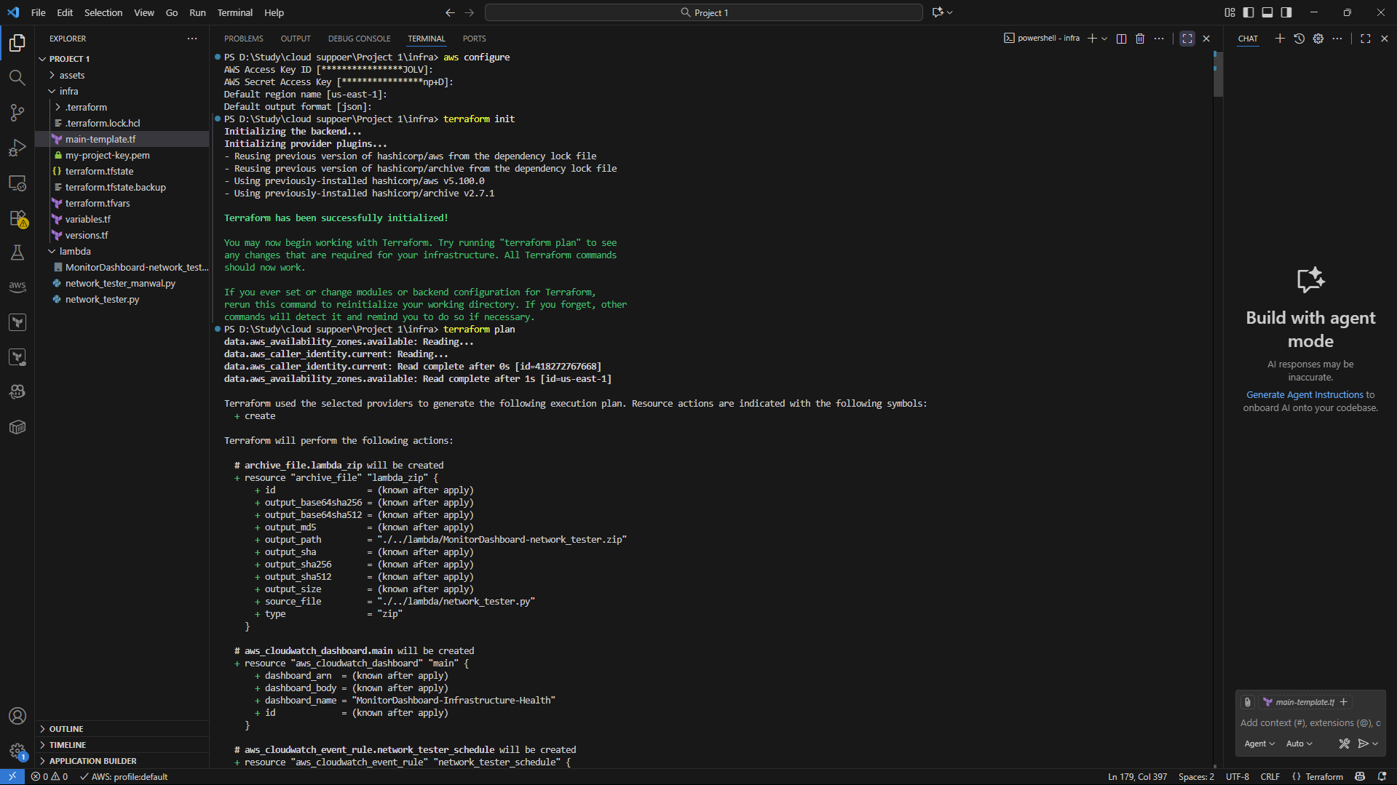

Phase 2: Deployment
Once the plan was verified, the infrastructure deployment was triggered. This process automatically provisioned the network (VPC), security groups, and resources.
Action: Ran terraform apply to begin resource creation.
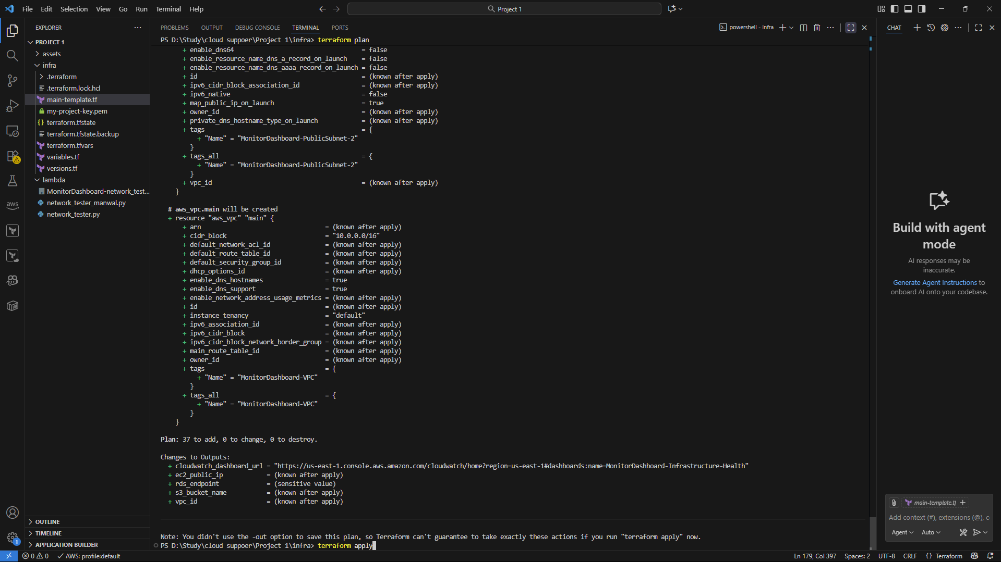

Phase 3: Deployment Completion & Outputs
After approximately 5 minutes, Terraform successfully provisioned all resources. The output block provided critical connection endpoints, including the Dashboard URL, EC2 Public IP, and S3 Bucket name.
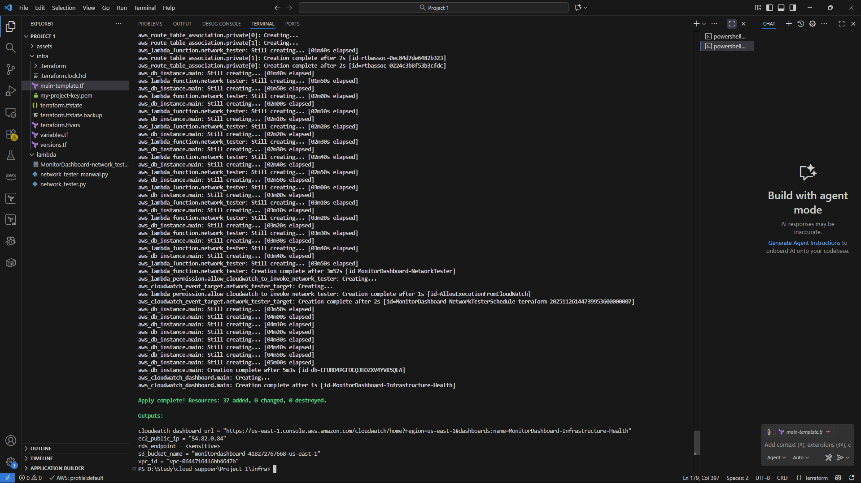

5. Network Configuration Verification
Before validating the application layers, we verified the underlying network infrastructure foundation.

A. Virtual Private Cloud (VPC)
A custom VPC (MonitorDashboard-VPC) was created to isolate the environment.
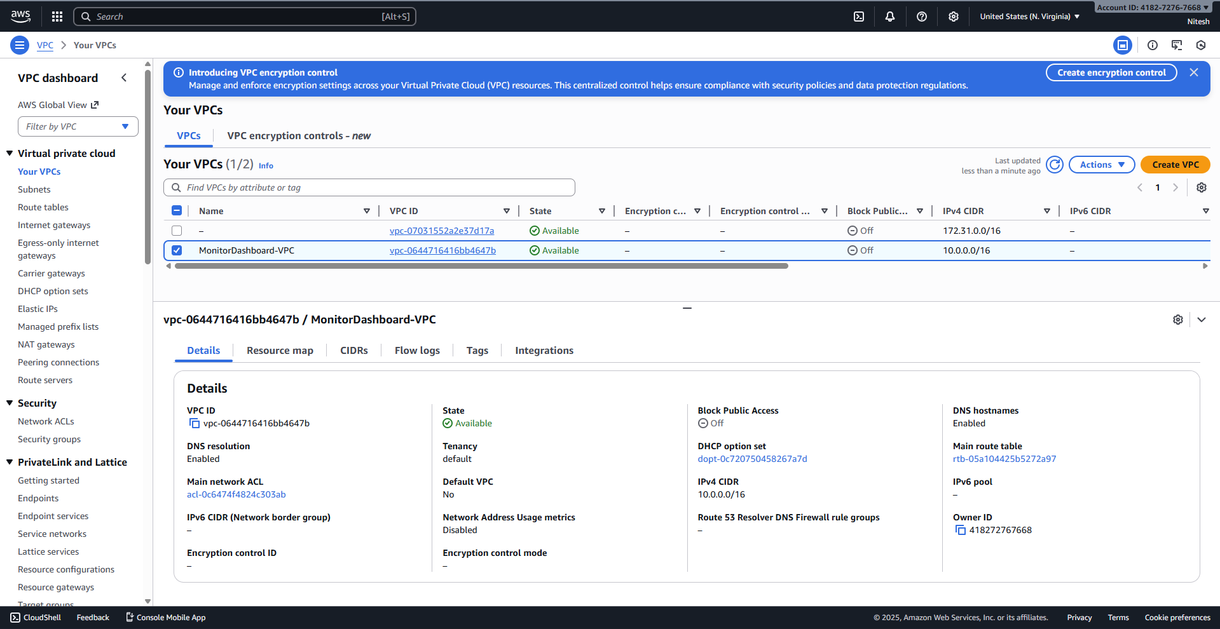

B. Subnet Configuration
The network was segmented into Public subnets (for the Web Server) and Private subnets (for the RDS database and internal Lambda functions).
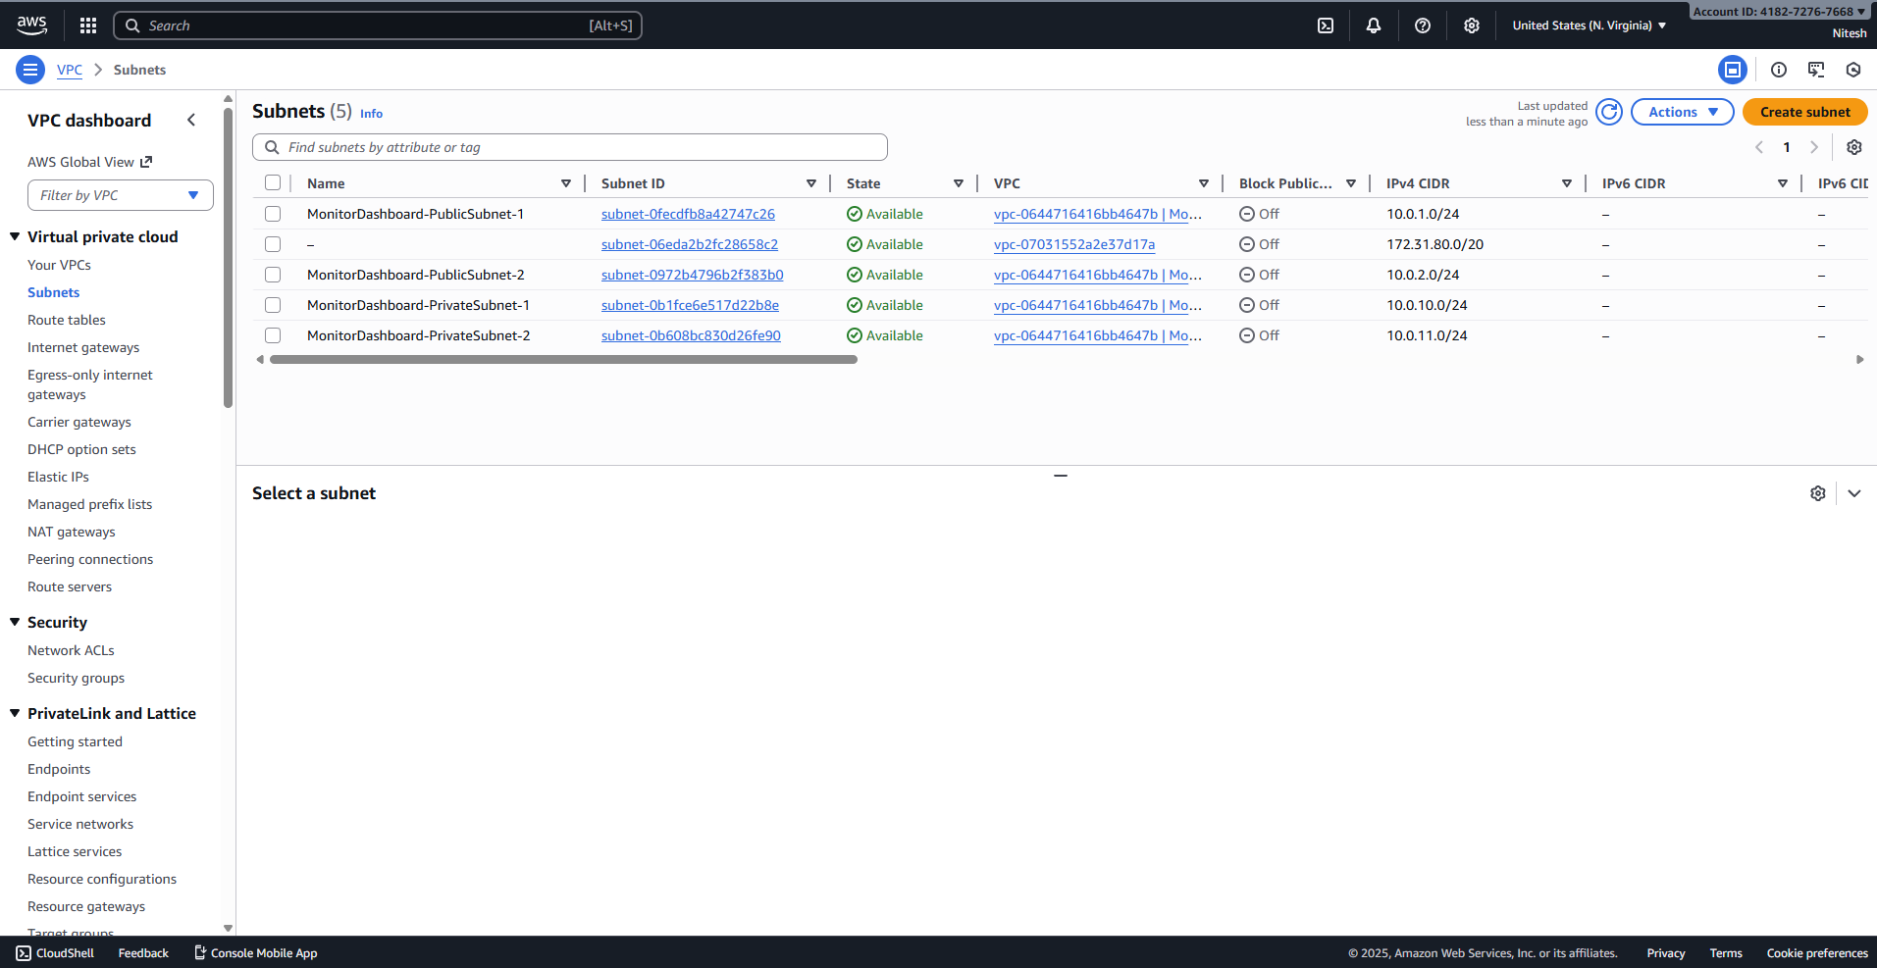

C. Route Tables
Custom route tables were configured to ensure traffic flowed correctly—public traffic via the Internet Gateway and private traffic via the NAT Gateway.
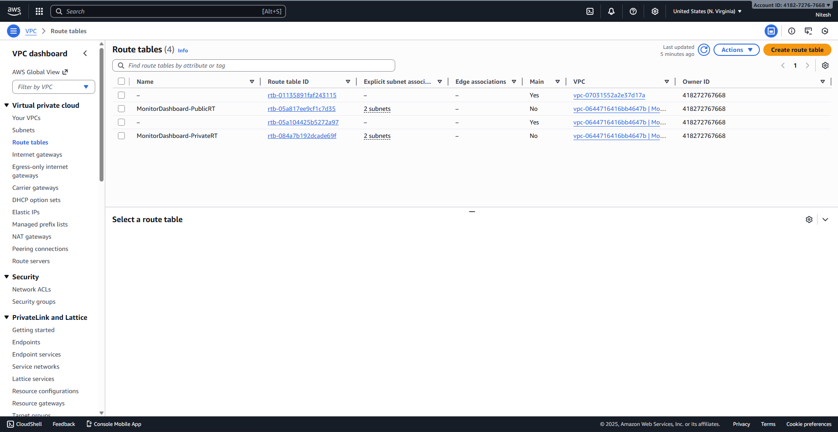

D. NAT Gateway & Elastic IP
To allow the private RDS instance and Lambda functions to access the internet (for updates/patching) without exposing them to incoming traffic, a NAT Gateway was deployed using an Elastic IP.
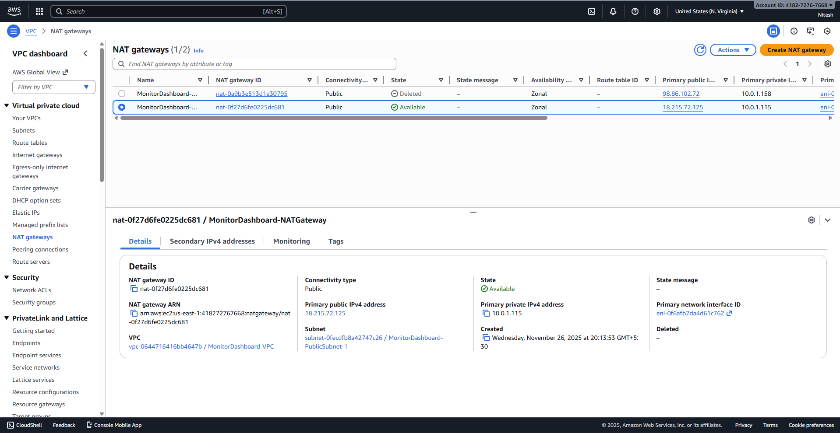
[Insert Screenshot 8 (16.png) here] Figure 8: Elastic IP allocation for the NAT Gateway.

6. Core Resource Verification

A. Compute (EC2)
We verified that the Web Server instance was successfully launched in the public subnet and passed all status checks.
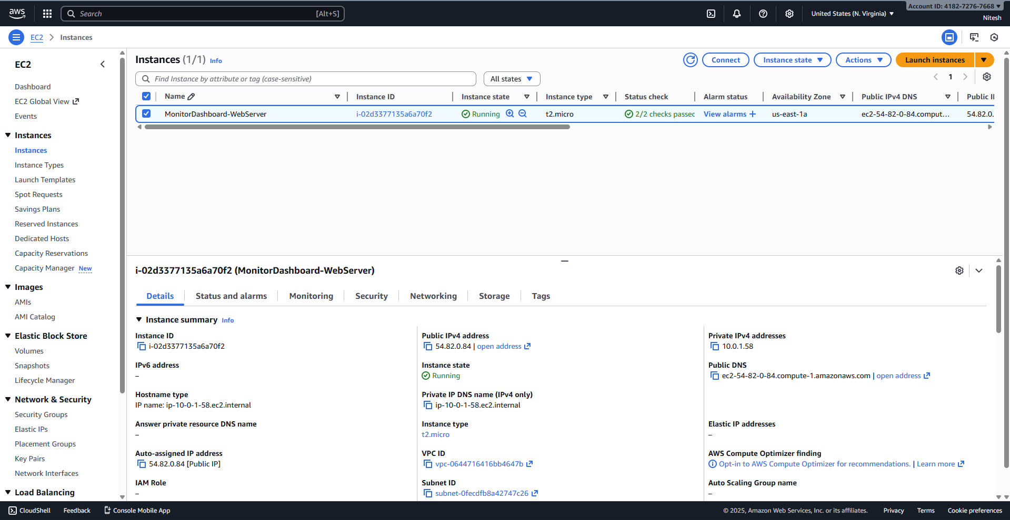

B. Storage (S3)
A unique S3 bucket was created to store application logs or static assets.
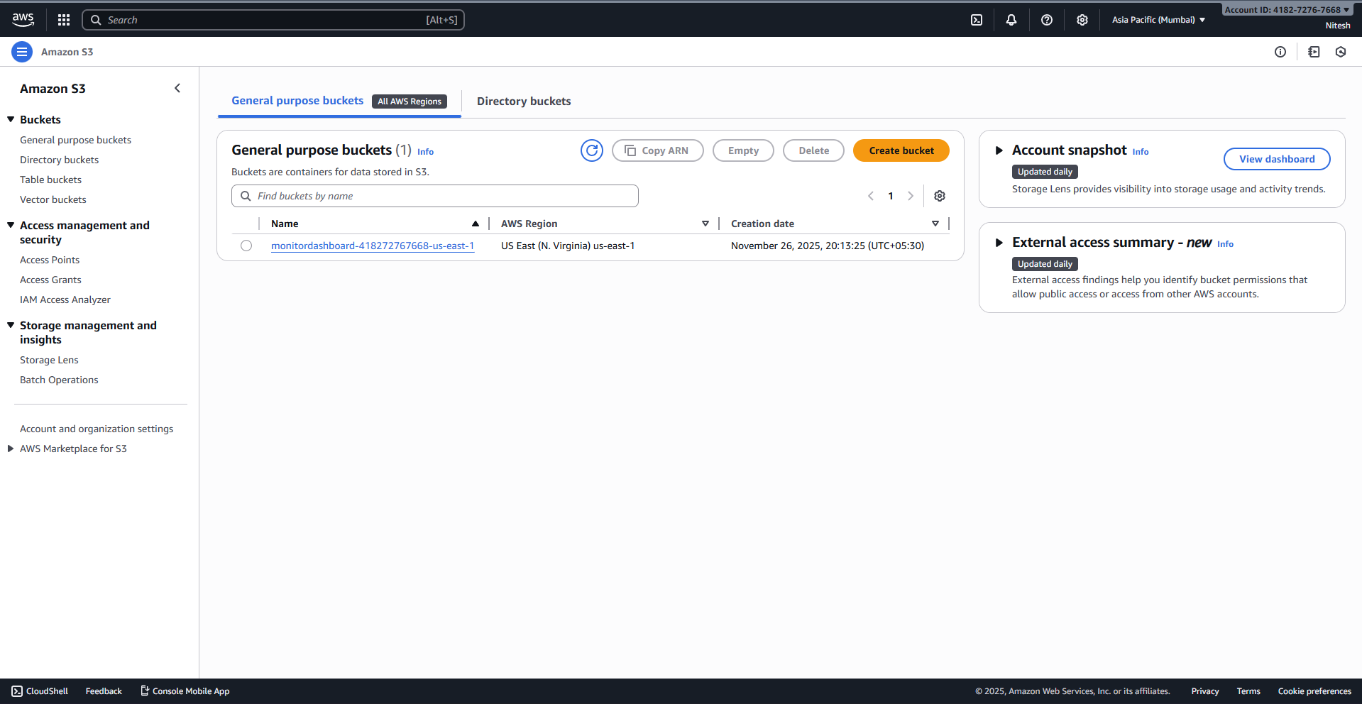

C. Database (RDS)
A MySQL RDS instance was provisioned within the private subnet groups, ensuring secure data storage.
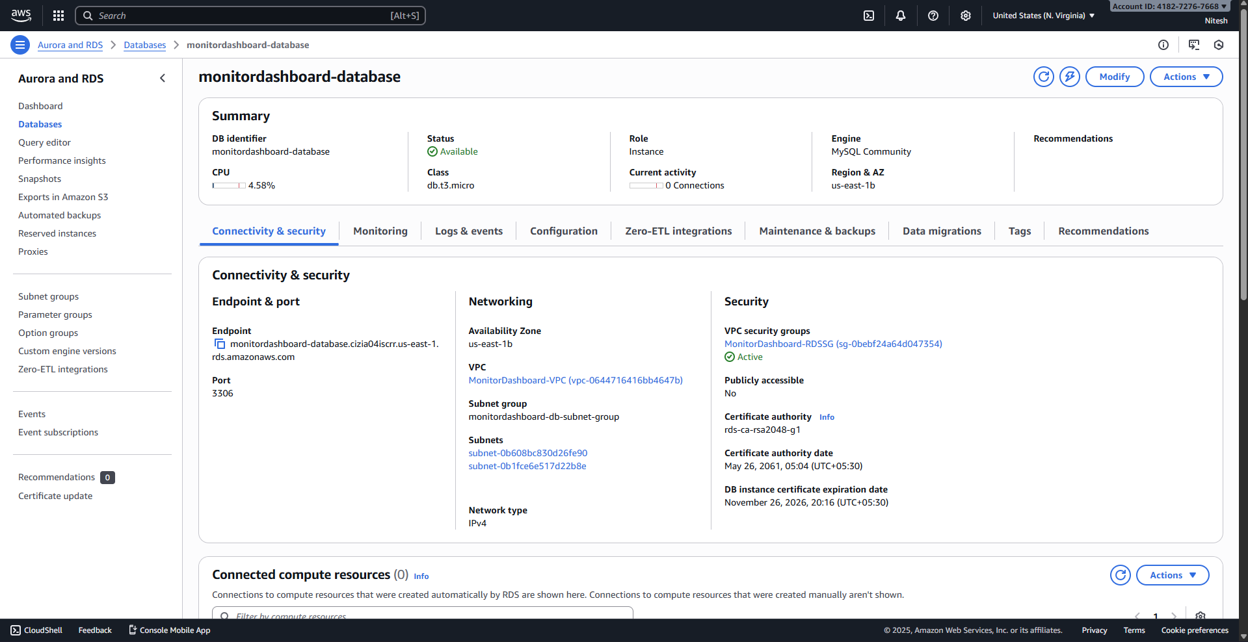

7. Serverless & Automation Verification

A. IAM Roles
Specific IAM roles were created to grant the Lambda function minimal necessary permissions to write to CloudWatch and access network resources.
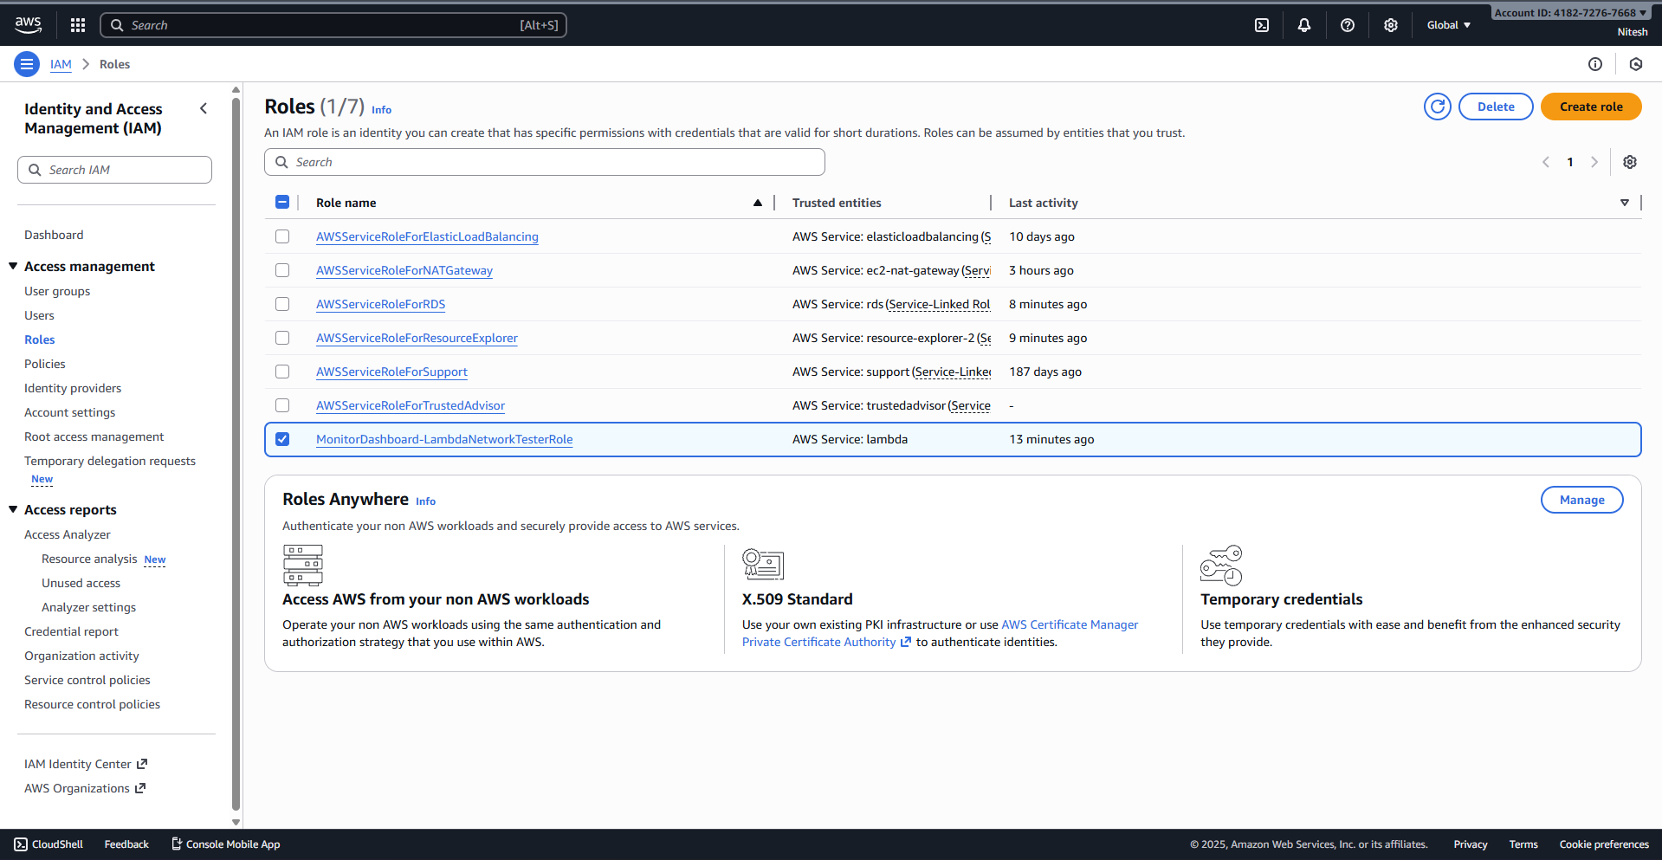

B. Lambda Function Deployment
A Python-based Lambda function was deployed to perform network reachability tests (e.g., checking connectivity to https://www.google.com/search?q=Google.com) to verify outbound internet access from the VPC.
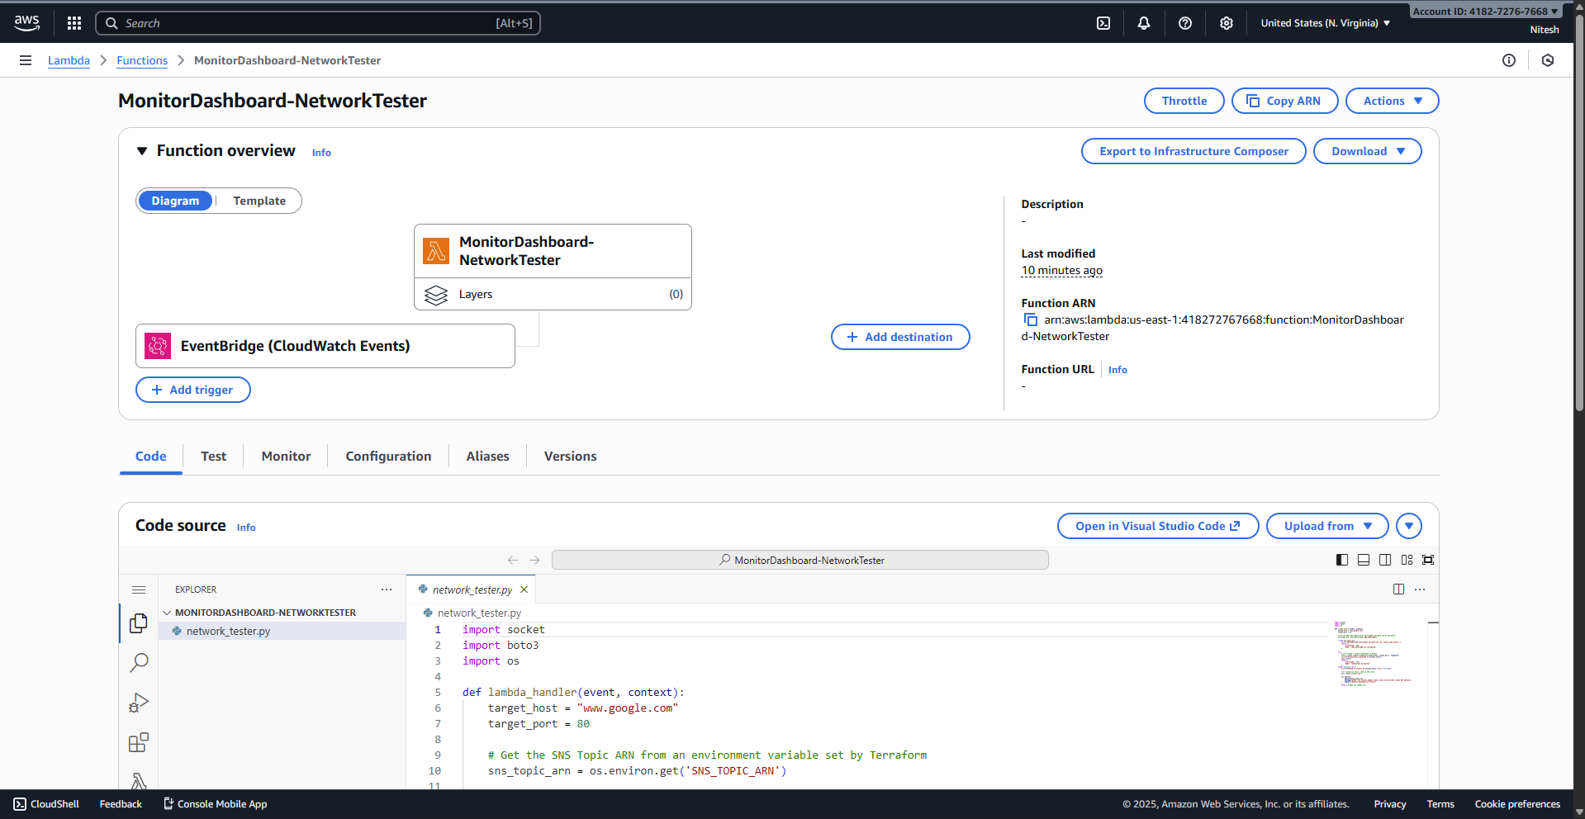

C. Function Testing
We manually invoked the Lambda function to verify it could successfully execute and reach external targets.
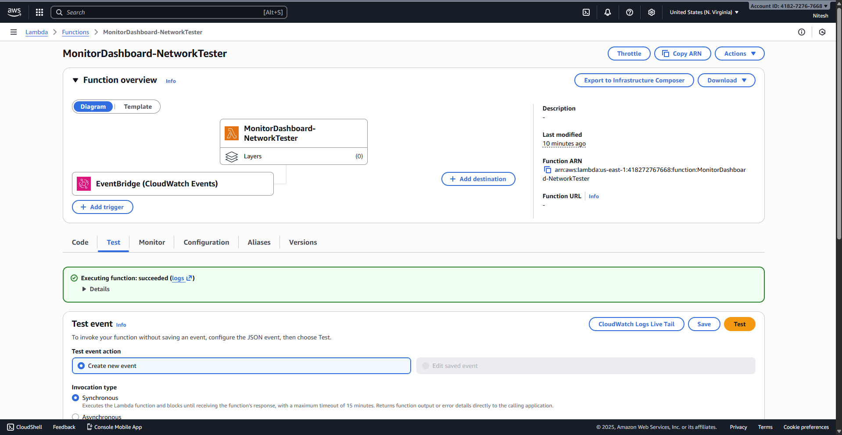

8. Monitoring & Observability

A. CloudWatch Alarms
An alarm was configured to trigger if the EC2 CPU utilization exceeds 80%, ensuring proactive incident response.
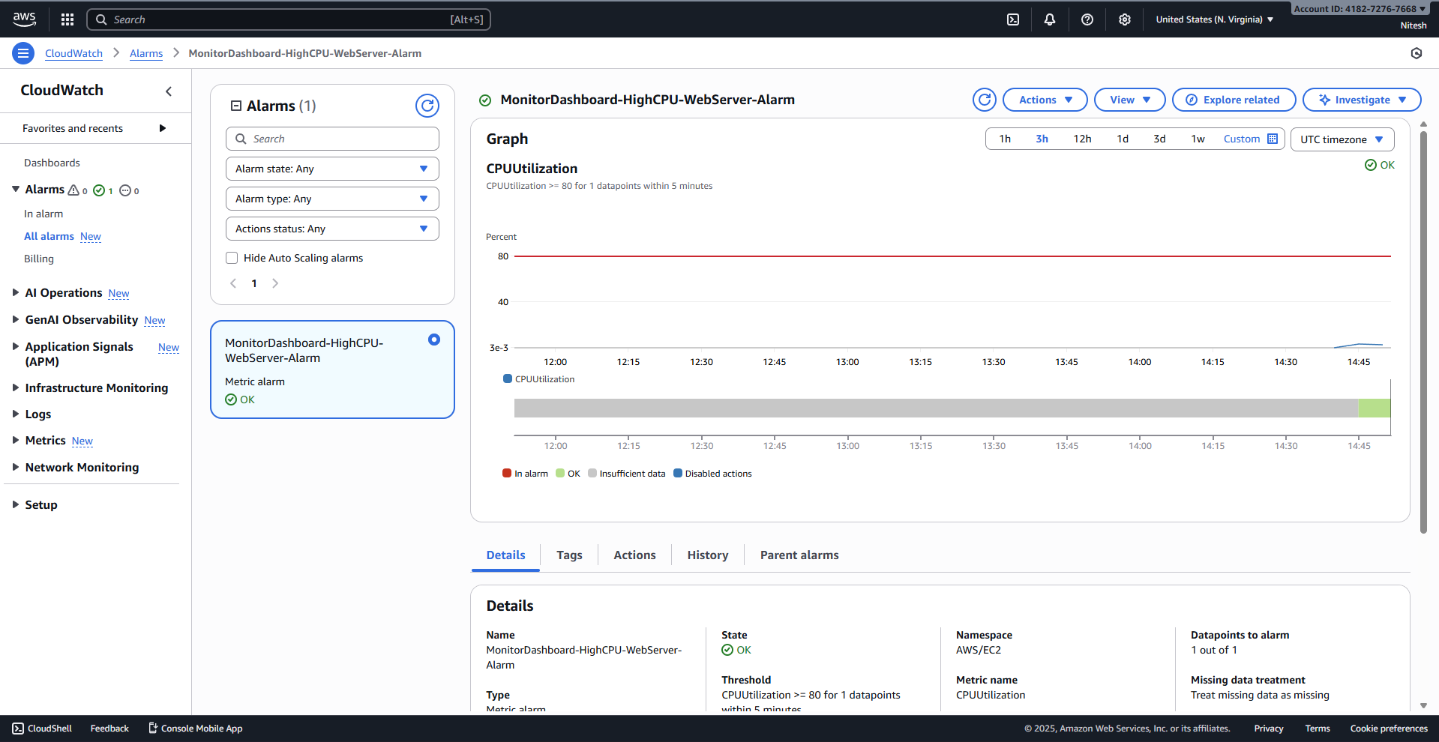

B. Unified Dashboard
The final artifact is the custom CloudWatch Dashboard, which aggregates metrics from EC2, S3, RDS, and the custom network tests into a single view.
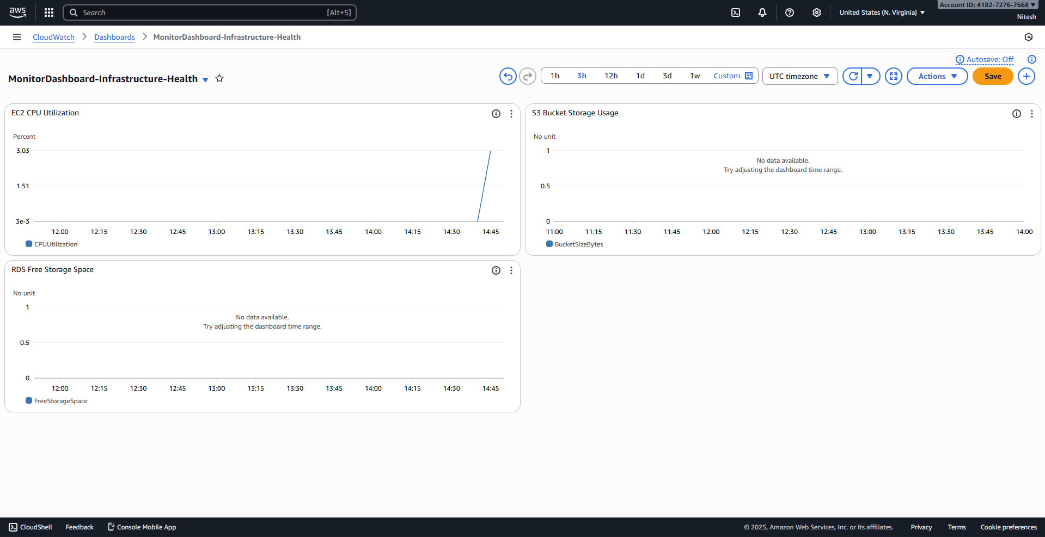

9. Cleanup & Teardown
To prevent unnecessary costs, the infrastructure was destroyed after the demonstration using Terraform's teardown capabilities.
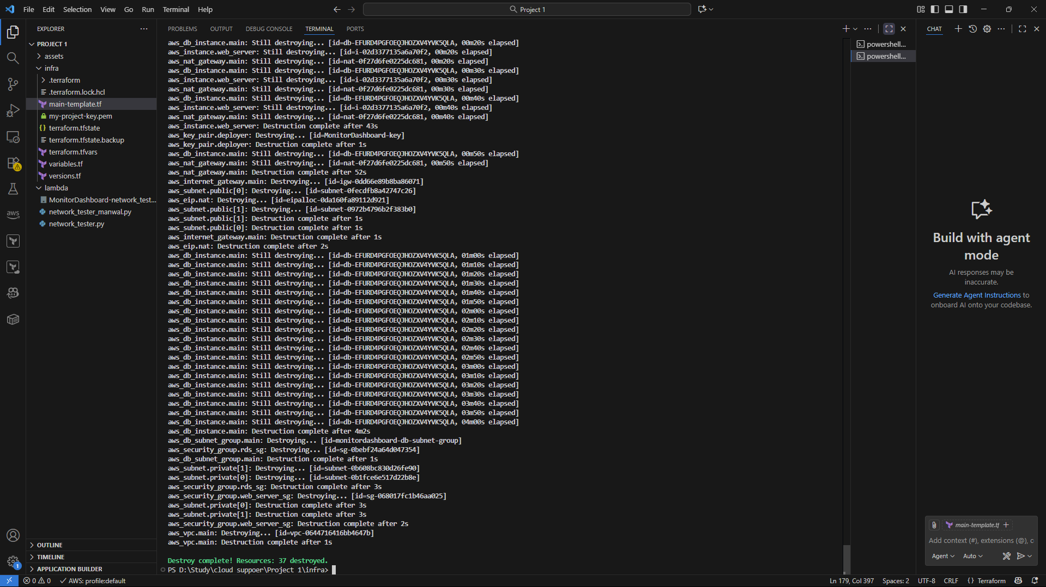

10. Conclusion
This project successfully demonstrated the power of Infrastructure as Code combined with AWS Observability tools. We automated the deployment of a robust 3-tier architecture—including complex networking, serverless automation, and databases—and established immediate visibility into its health. This solution provides Cloud Support teams with a reliable, automated method to monitor critical infrastructure health.

